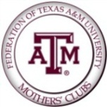

THE WINTER AGGIE MOM DINNER

YOU ARE INVITED TO DINNER
All Aggie Moms, Dads, and Aggies Are Welcome!

Place and Time:
The Association of Former Students
Clayton W. Williams, Jr. Alumni Center
505 George Bush Dr.
College Station, TX 77840

Friday, January 20, 2017

6:00 PM REGISTRATION & SOCIAL TIME

6:30 PM SPEAKER
Special Guest Speaker: Chris Field,
Founder and Executive Director of
Mercy Project

DINNER TO FOLLOW

$30 per Person

Salad

6 oz. Top Sirloin Steak

Spinach and Smoked Bacon Potato Lyonnaise with
Balsamic Red Wine Demi Glace

Dinner rolls and Butter
Iced Tea
Desert

http://www.signupgenius.com/go/

RSVP & Payment Deadline ~ Wednesday, January 11, 2017
Checks payable to Federation of Texas A&M Mothers’ Clubs

Katie McMordie Latham’80
5 Lime Cove Lucas, TX 75002
kmlatham@keeva.net
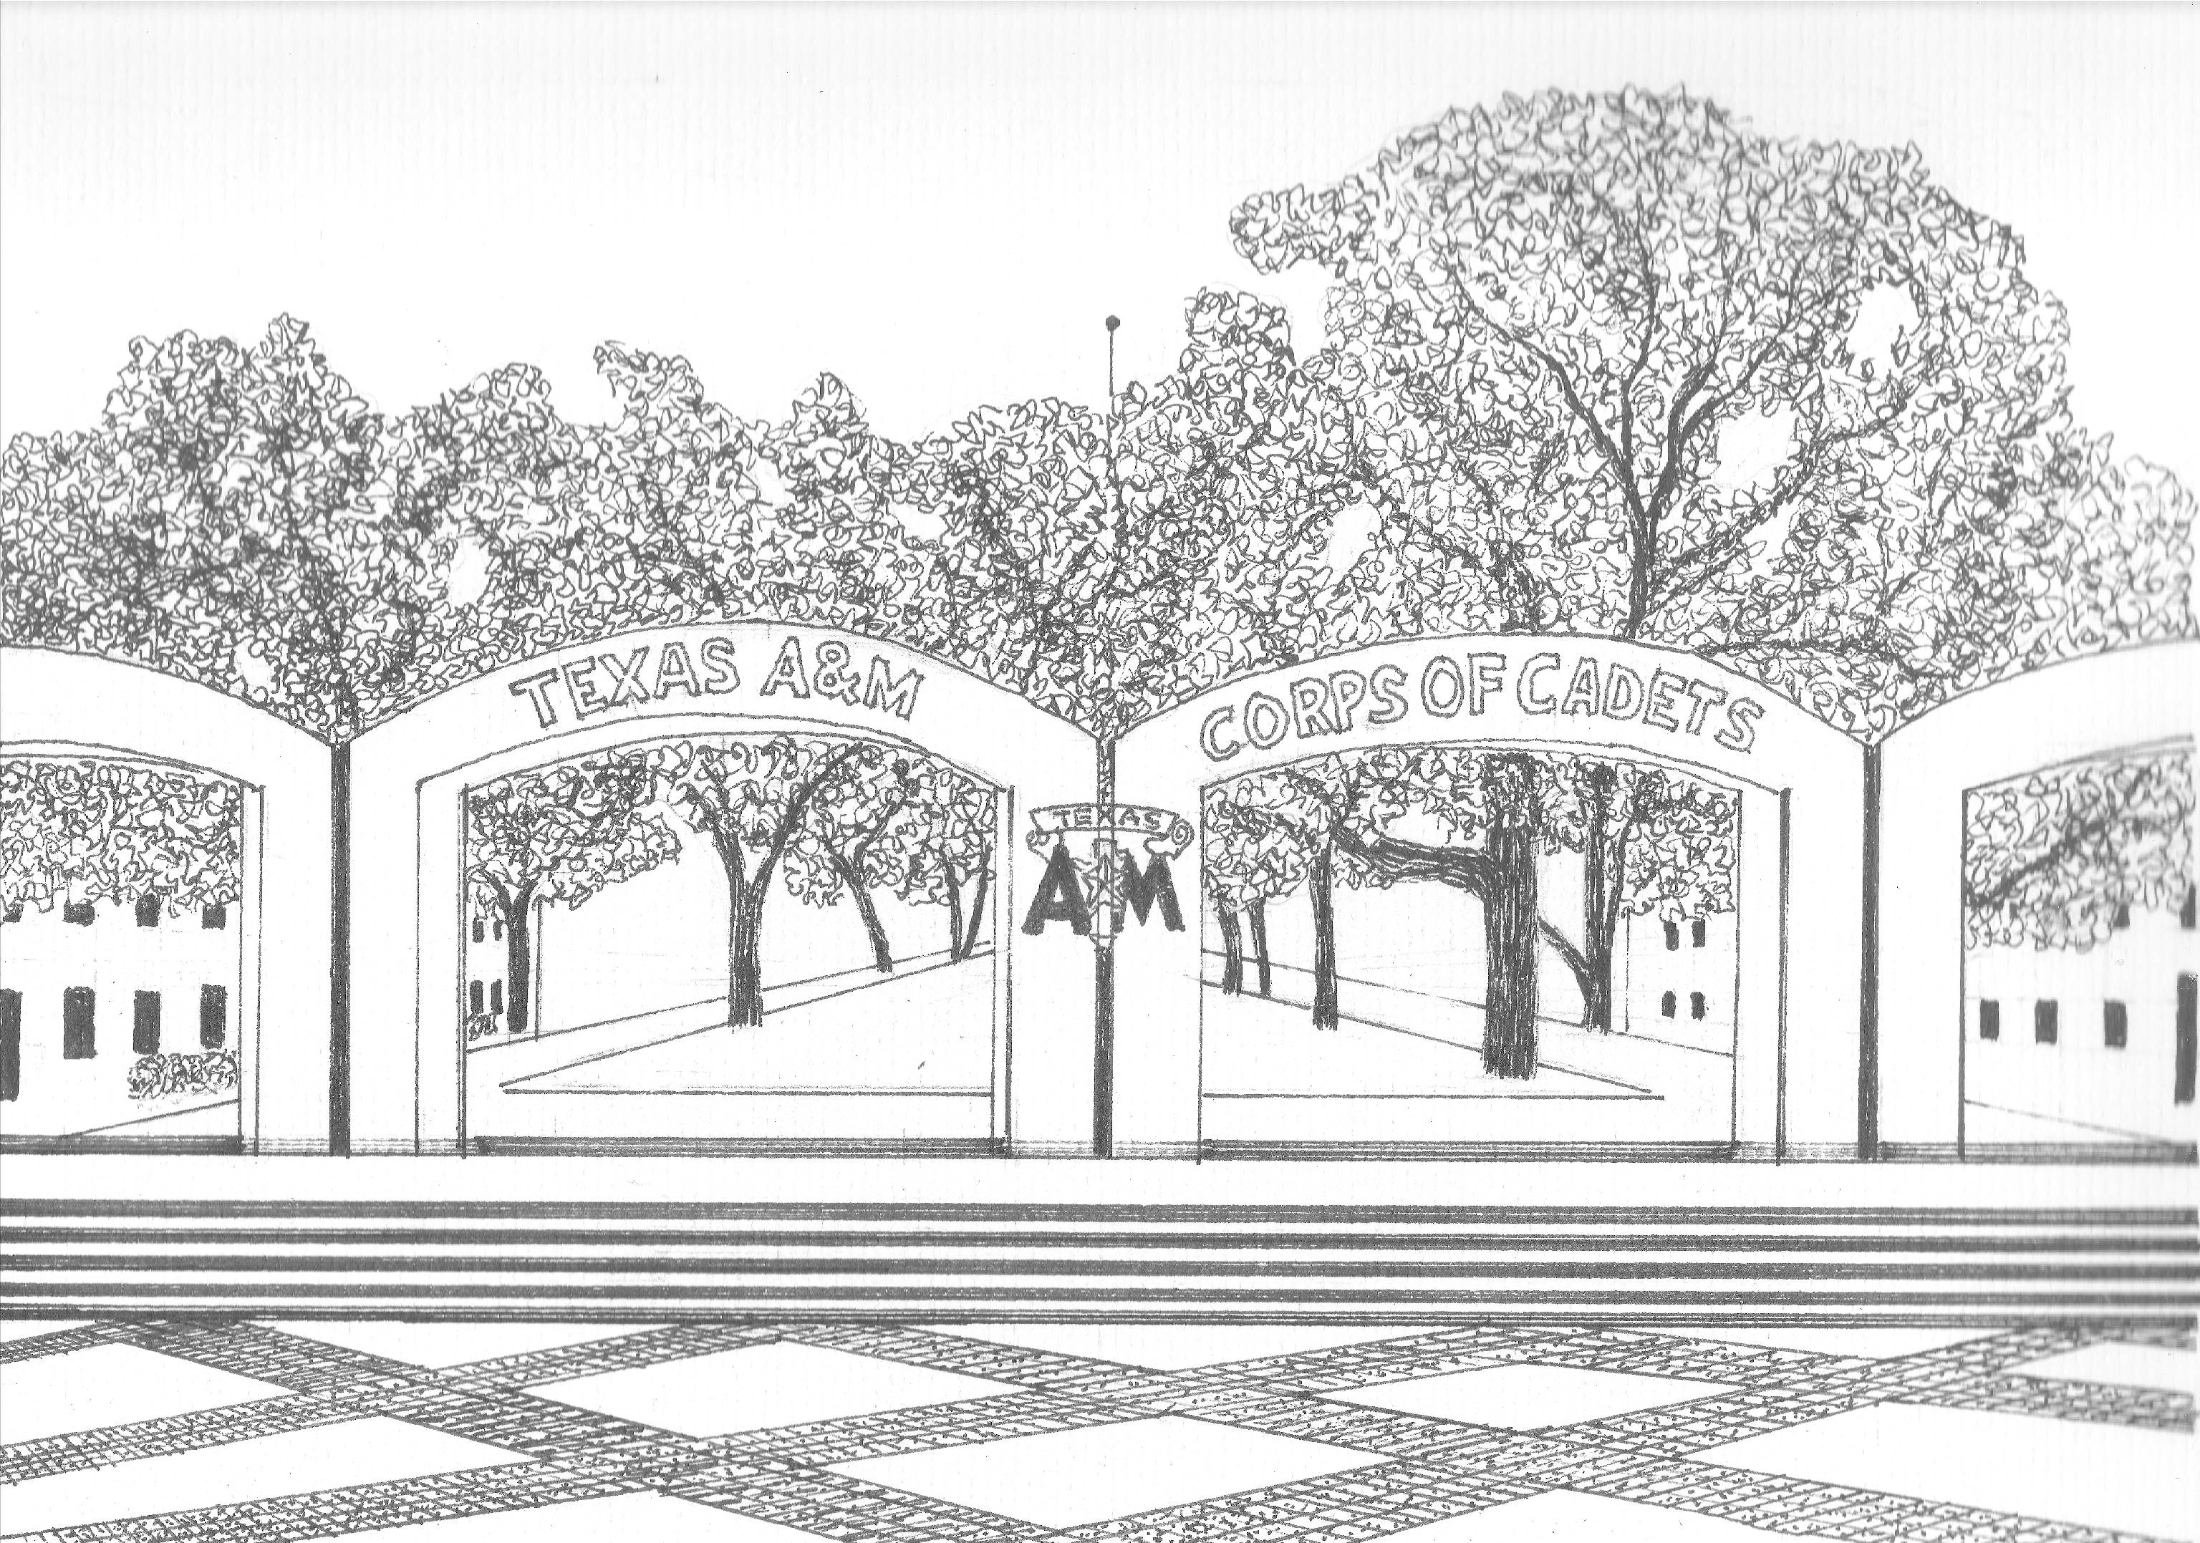
Aggie Moms United With the Corps In Keeping The Aggie Spirit

