  - Parker County Aggie Moms Club

Technology Used for Sales for 2018-2019
  - Compiled by Catherine Stanley, President 2018-2019 – August 21, 2019
Any opinions expressed in this document are my own.

Howdy Party 2019
Parker County Aggie Moms
Used Square Online Store for Ticket Sales

Created Buttons to link to Ticket Sales: (See Max Buttons – there are lots of add-ins available)

SETTING UP SQUARE ONLINE
Note: there are multiple options, but if you want a very simple store, choose the Square Online (not the Weebly) – last time I checked it was a single line at the bottom under all the other options and I missed it more than once
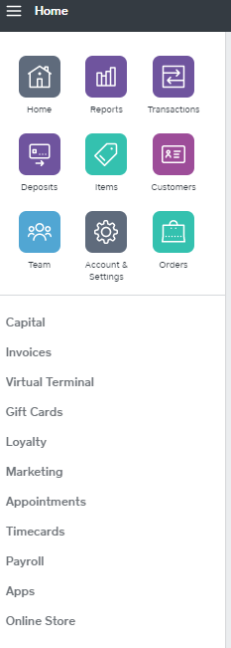

In Square choose Online Store at Bottom

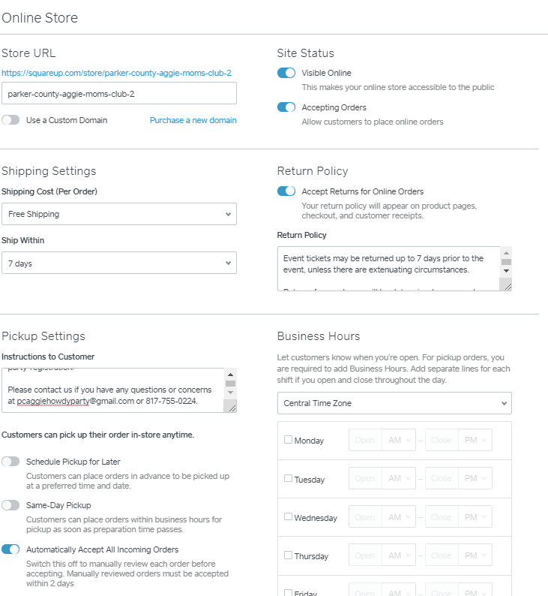

Pickup Settings: Instructions to Customer
Howdy! Thank you for your support of Parker County Aggie Moms and our upcoming Howdy Party.
Please take a few moments to complete the registration process. This will expedite "check-in" at the event and allow us to create name tags and other customized information for our guests.
The registration form is located at:
https://parkercomoms.aggienetwork.com/2019-howdy-party-registration/ (THIS IS WHAT WE USED TO LINK TO THE REGISTRATION FORM IN WORDPRESS – EXAMPLE IS LATER)
Please contact us if you have any questions or concerns at pcaggiehowdyparty@gmail.com or 817-755-0224.

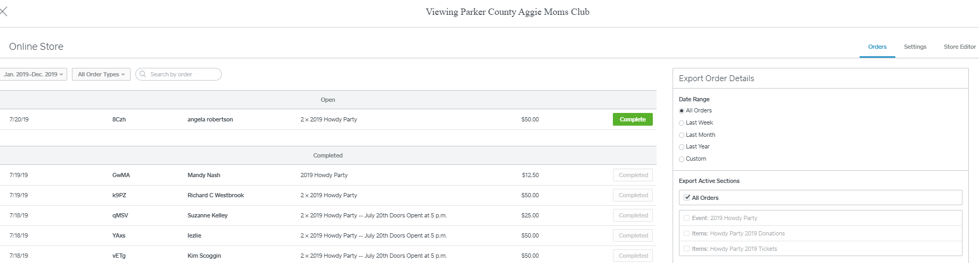
To build – select Store Editor – can add sections and reorder, as well as, add icons and photos.
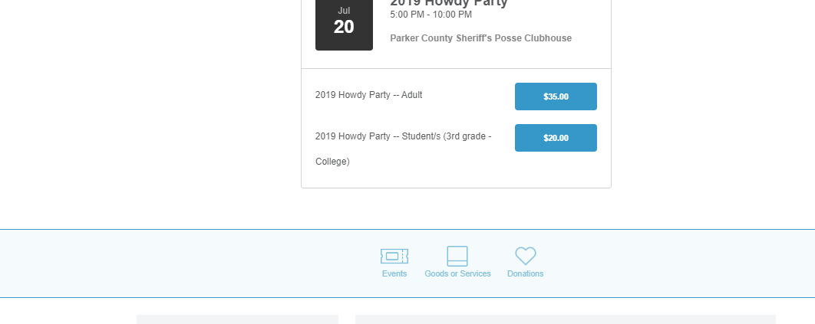
WARNING! If you delete an item out of square, it will remove from the Online Store too!
Other Notes – sales are typically deposited daily, which can create headaches for treasurer with daily deposits and tracking. There may be a way to have deposits on a weekly basis to make tracking easier. However, at least sales are actually tracked, which with having 20 moms selling tickets – tracking funds is a challenge.

Max Buttons – used to create buttons.

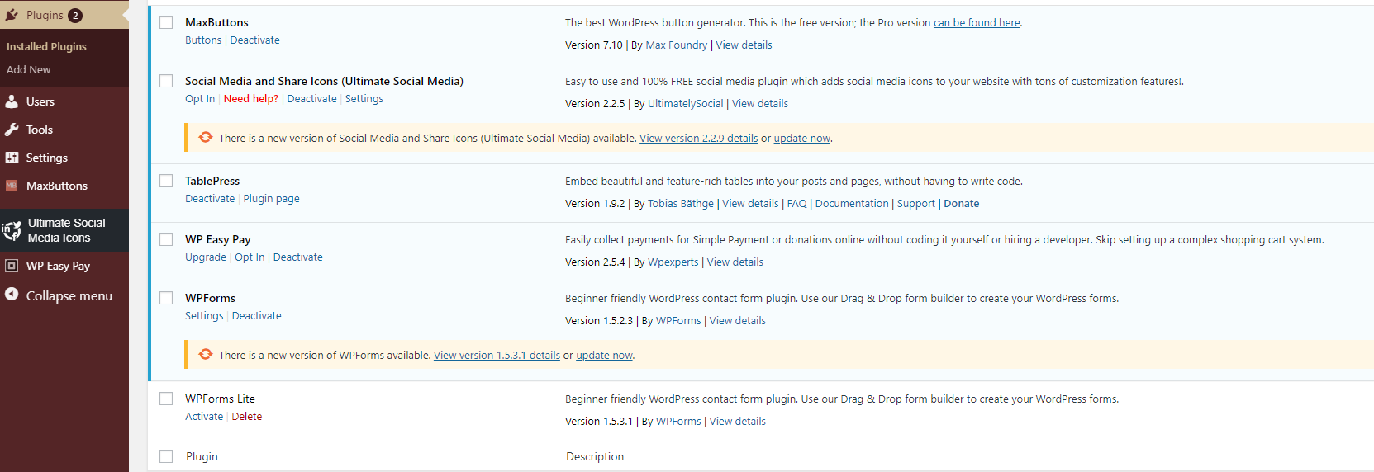

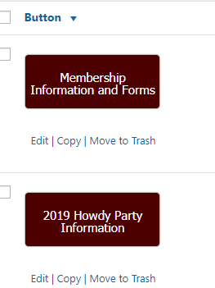

Table Press – Used to create Tables, such as:
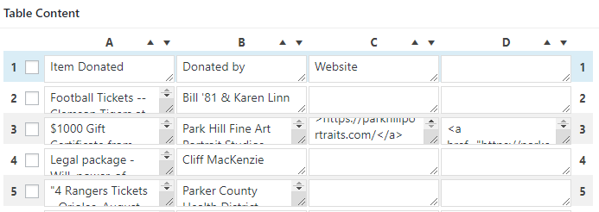
PREVIEW:

WP Forms – we paid a fee for this plugin. It allows us to create forms and collect data within the Aggie Network Word Press Website. There is free option but you can’t download data in CSV/Excel format. We could have used Google Forms, but we were already having them go to an external website to purchase tickets through Square, so we felt it helped with integrity to keep them on a page within the AggieNetwork website to collect this data. (that decision was before we realized that we could not download the CSV without a fee – and sheer exhaustion let to just pay the $35-40 and be finished)
Edit Screen
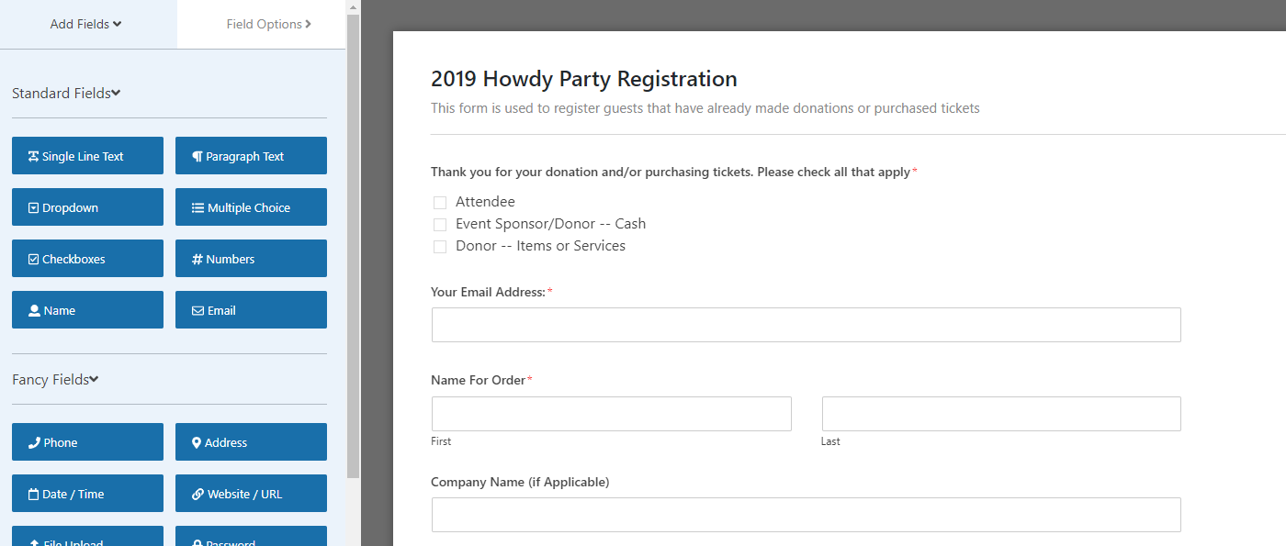

WP Forms Preview:
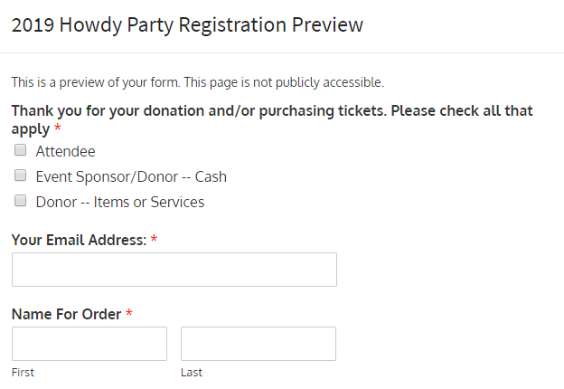
Entries which can be exported and pulled into another document.
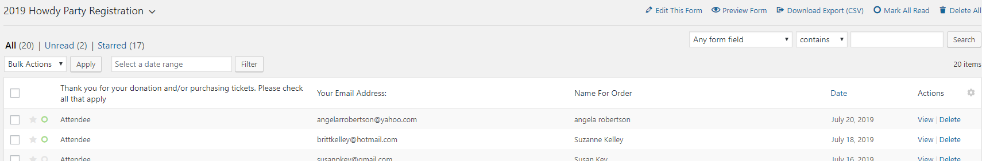

This information could then be used to create name tags, bid numbers, etc.
Note: this process also required having someone verify that they folks that purchased tickets also registered to get name tags generated for the event.
Cost: Square has a fee of around $.40/transaction (not per ticket) and then the standard credit card processing fees. Significantly less than Eventbrite

SINGING CADET Concert Ticket Sales – Our club had over 500 tickets sold! The hosting church sold 100 tickets and the remainder were sold through Eventbrite.
We sold 403 tickets through EventBrite. Tickets were sold at $10/each plus the payment processing fee. Eventbrite credit fees were $108.81 and the Eventbrite Service Fees were $398.97. This was SOOO easy. We were easily able to have multiple people checking guests in with their cell phones. Note – we were not generating name tags for guests or anything along those lines. However, if we had used Square – we had 142 transactions, so the service fee would have been less than $70, compared to approximately $400. The ease of Eventbrite may still make it worth the extra $$$.
https://www.eventbrite.com/e/texas-am-singing-cadets-concert-in-aledo-parker-county-tickets-50426508043#
Approximately 10 days after the event, the amount was deposited (ONE-TIME Deposit – think easy for treasurer) into our account. Here is a sample report:
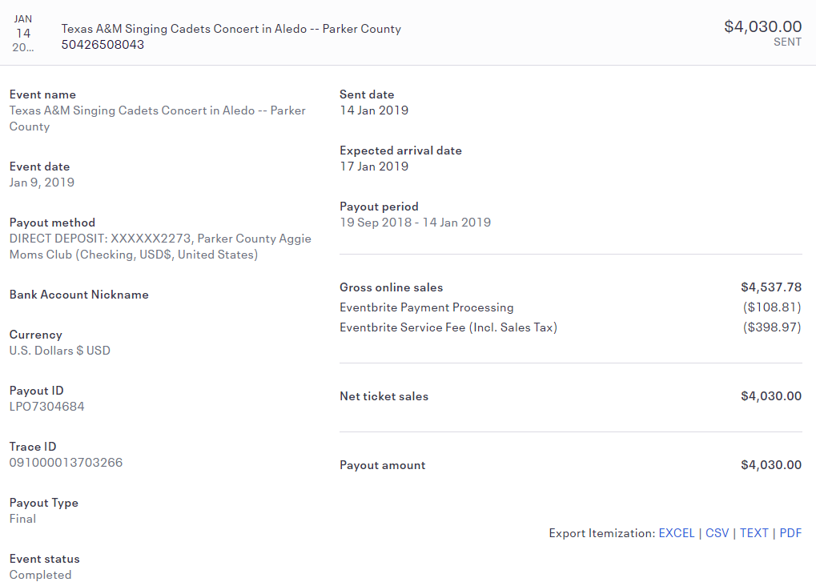

Additionally – you can get a report with all the order information – here is the header:

There are options to create name tags, etc., but we did not use those.
GETTING THE WORD OUT – the Association of Former Students sent an e-mail blast to ALL A&M Graduates residing in Parker County and neighboring A&M Clubs (to send to neighboring clubs, the local club president must approve). This is a GREAT way to reach out to Former Students for upcoming Aggie Events.
Our club was able to arrange a FUN time at the local bowling alley complete with pizza and game tickets for the Cadets PRIOR to the evening concert. It was such a blast to see them having a great time! (Cost was approximately $1500)
And then the Singing Cadets put on an AMAZING SHOW! Even my Red Raider husband enjoyed it.

